Payroll management system for Information Technology company

Use-Case Specification: Log in

Version 1.0

Revision History

|  |  |  |  |
| --- | --- | --- | --- |
| **Date** | **Version** | **Description** | **Author** |
| 28/12/2019 | 1.0 | Final | Nguyen Khac Phuc |
|  |  |  |  |
|  |  |  |  |
|  |  |  |  |

Table of Contents

1. Log in 4

1.1 Brief Description 4

2. Flow of Events 4

2.1 Basic Flow 4

3. Special Requirements 4

3.1 < Valid username and password > 4

4. Preconditions 4

5. Postconditions 4

6. Extension Point 5

Use-Case Specification: Log In

# Log in

## Brief Description

This is the first step to access the system, users can easily log in the system with their own username and password

# Flow of Events

## Basic Flow

First the log in view will appear, then users fill in their username and password. After that, users click on Log In button. Eventually, the system will redirect to the view corresponding to the position which users are take part in.

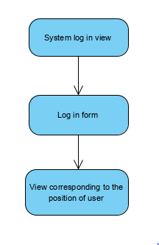

## Actor

-Administrator, Employee, Accountant

# Special Requirements

## Valid username and password

- Username and password which entered by users must valid.

# Preconditions

* Users must be an official staff in the company and they already have an account

# Postconditions

* Show success message if user log in successful and redirect to corresponding view or show failed message if the username or password is incorrect

# Extension Point

* Users information should be secured